
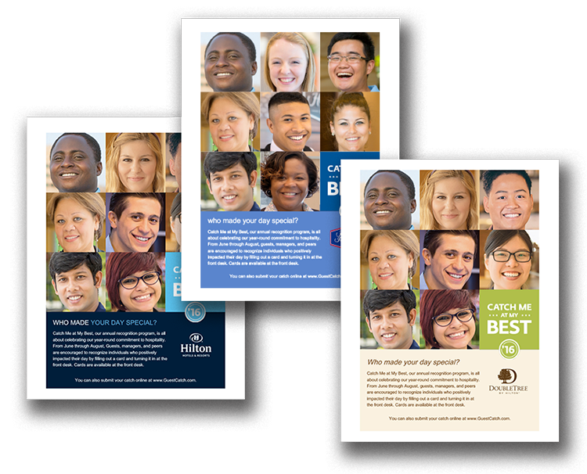
Promote Guest Catches at Your Location

Like any successful recognition initiative, Catch Me at My Best requires some effort to create awareness among guests and Team Members. Simply leaving cards at the front desk isn’t always enough. Use
the poster on the following page to let guests know about Catch Me at My Best. Print and display throughout your location. You can even place in guest rooms. All content is customizable, including fonts and language.
June 1 – August 31, 2016

CATCH ME AT MY BEST








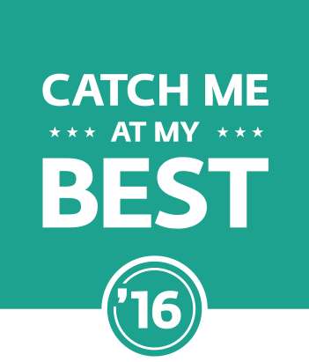


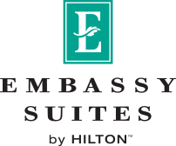
Who Made Your Day Special?

Catch Me at My Best, our annual recognition program, is all about celebrating our year-round commitment to hospitality. From June through August, guests, managers, and peers are encouraged to recognize individuals who positively impacted their day by filling out a card and turning it in at the front desk. Cards are available at the front desk.
You can also submit your catch online at www.SubmitMyCatch.com.

