
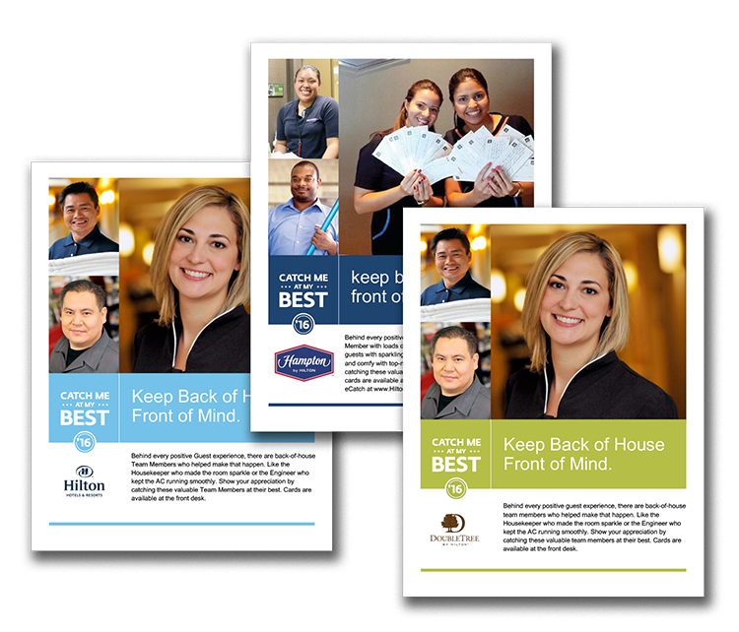
Promote Back-of-House Catches at Your Location.

Behind every positive guest experience, there are back-of-house Team Members who helped make it happen. Use the poster on the following page to promote back-of-house catches. Print and display in your break room, by your time clock, and in other team common areas. All content is customizable, including fonts and language.

June 1 – August 31, 2016

CATCH ME AT MY BEST



Behind every positive guest experience, there are back-of-house Team Members who helped make that happen. Like the Suitekeeper who made the room sparkle or the Engineer who kept the AC running smoothly. Show your appreciation by catching these valuable Team Members at their best. Cards are available at the front desk. You can also submit an eCatch at www.Hilton-Recognition.com/eCatch.

Keep Back of House Front of Mind.

