
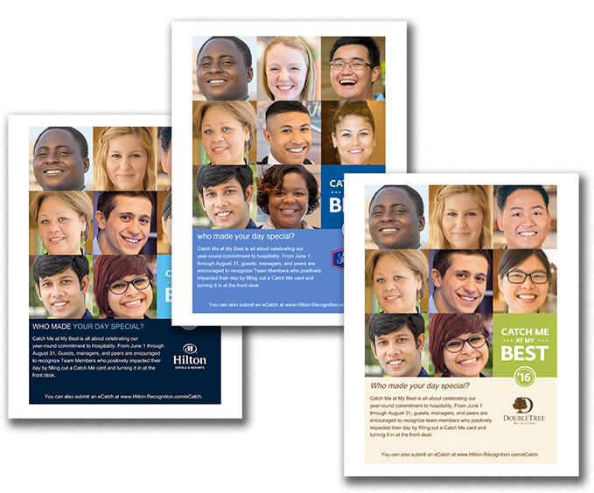
Build Internal Awareness About Catch Me at My Best

Use the poster on the following page to promote internal awareness among Team Members. Print and display in your break room, by your time clock, or in other team common areas. All content is customizable, including fonts and language. Please note that this poster is intended for internal use only.

June 1 – August 31, 2016

CATCH ME AT MY BEST


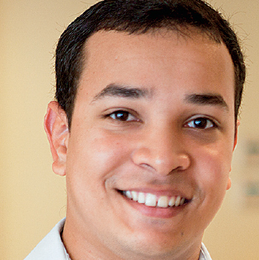

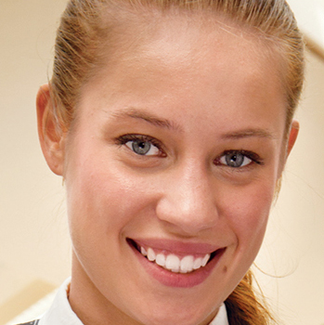
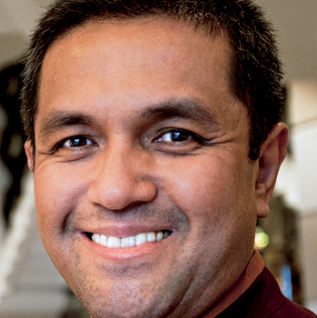


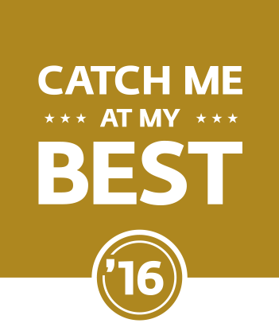



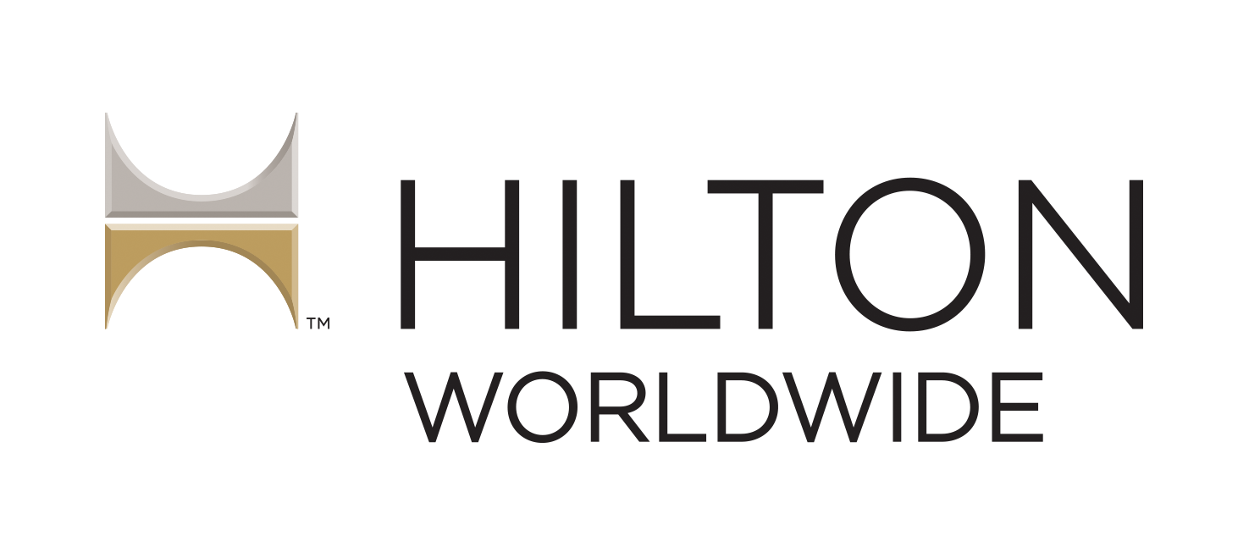
WHO MADE YOUR DAY SPECIAL?

Catch Me at My Best is all about celebrating our
year-round commitment to living the Hilton Worldwide Values. From June 1 through August 31, managers and peers are encouraged to recognize Team Members who positively impacted their day by submitting
an eCatch at www.Hilton-Recognition.com/eCatch.

