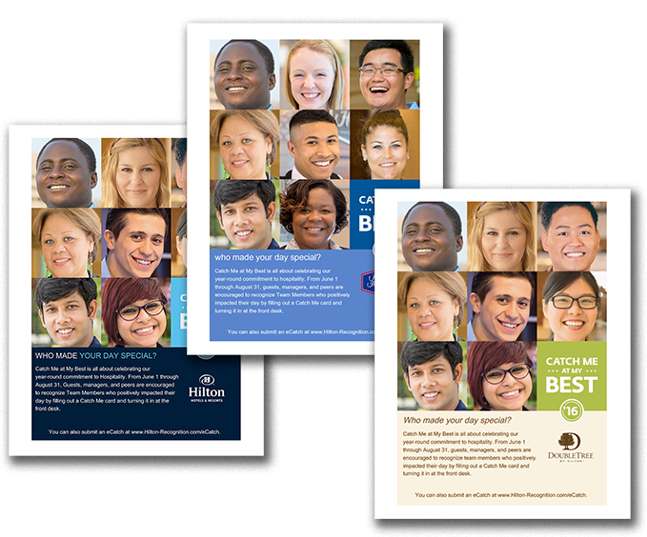

CATCH ME AT MY BEST

June 1 – August 31, 2016

Build Internal Awareness About Catch Me at My Best

Use the poster on the following page to promote internal awareness among Team Members. Print and display in your break room, by your time clock, or in other team common areas. All content is customizable, including fonts and language. Please note that this poster is intended for internal use only.

You can also download posters to promoting the following:

* GUEST CATCHES. Place throughout your location for guests to see. You can even place these in guest rooms.
* PEER CATCHES. Why let guests have all the fun? Use this to encourage your Team Members to catch each other.
* BACK-OF-HOUSE CATCHES. Use this to encourage your team to catch back-of-house Team Members.

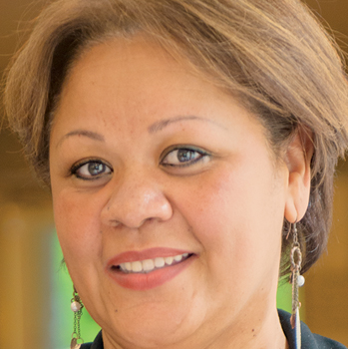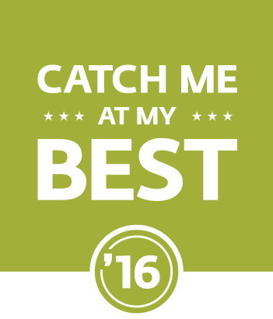

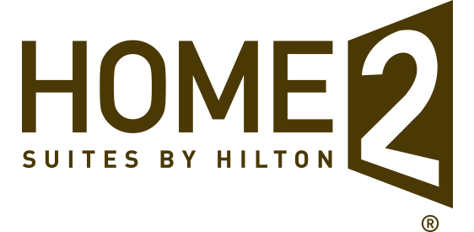

WHO MADE YOUR DAY SPECIAL?

Catch Me at My Best is all about celebrating our   
year-round commitment to hospitality. From June 1 through August 31, guests, managers, and peers are encouraged to recognize Team Members who positively impacted their day by filling out a Catch Me card and turning it in at the front desk.

You can also submit an eCatch at www.Hilton-Recognition.com/eCatch.