
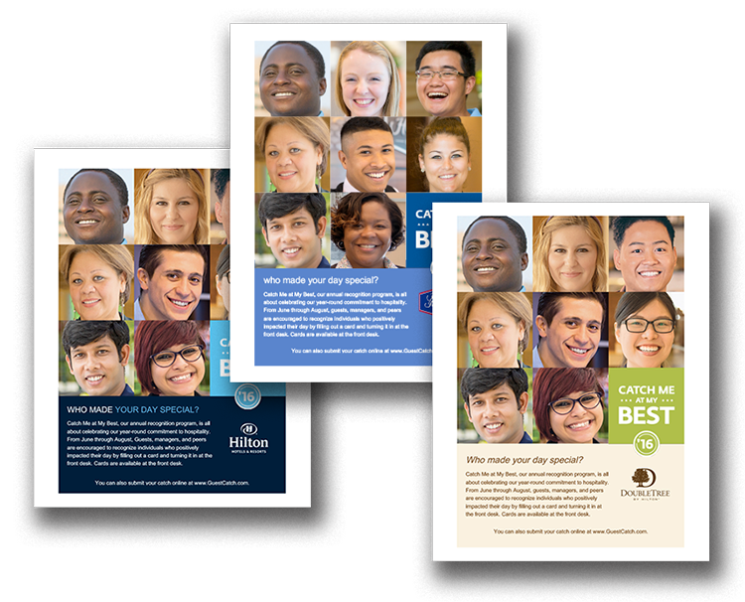
Promote Guest Catches at Your Location

Like any successful recognition initiative, Catch Me at My Best requires some effort to create awareness among guests and enthusiasts. Simply leaving cards at the front desk isn’t always enough. Use
the poster on the following page to let guests know about Catch Me at My Best. Print and display throughout your location. You can even place in guest rooms. All content is customizable, including fonts and language.
June 1 – August 31, 2016

CATCH ME AT MY BEST


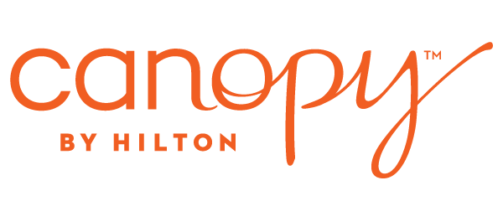







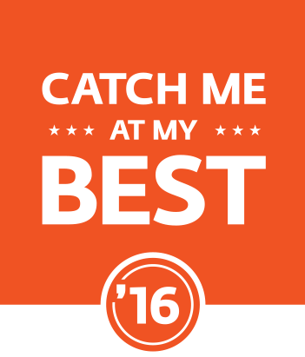

Who made your day special?

Catch Me at My Best is all about celebrating our
year-round commitment to hospitality. From June 1 through August 31, guests, Leads, and peers are encouraged to recognize enthusiasts who positively impacted their day by filling out a Catch Me card and turning it in at the Welcome Desk.

You can also submit your catch online at www.SubmitMyCatch.com.

