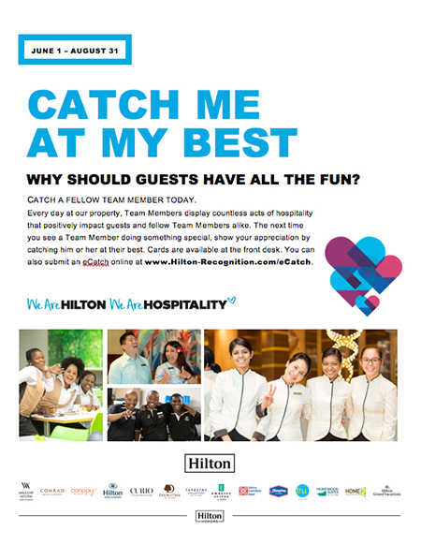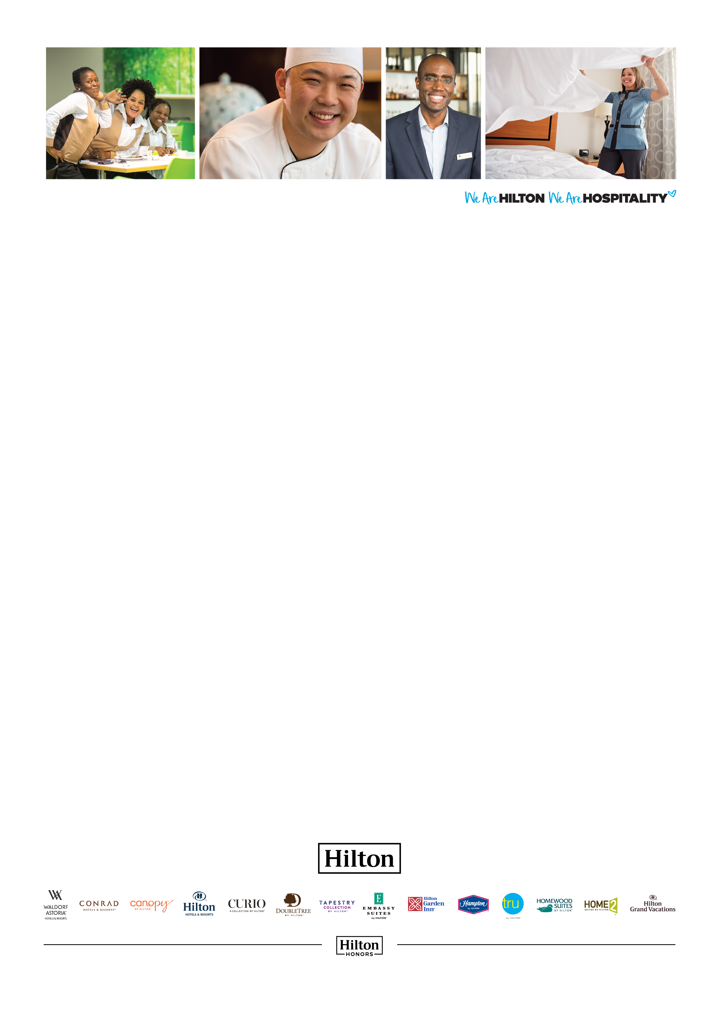

PROMOTE PEER CATCHES AT YOUR LOCATION

When surveyed last year, almost 25% of hotels said that catches were submitted by Guests only! Hotels that get the most out of Catch Me place an emphasis on getting Team Members to catch each other. Use the poster on the following page to promote peer catches. Print and display in your break room, by your time clock, or in other team common areas. All content is customizable, including fonts and language.

The headline font is Arial Black, which is standard on many computers. If you don’t have Arial Black, we recommend you use a sans serif font in a similar bold weight.

CATCH ME

AT MY BEST

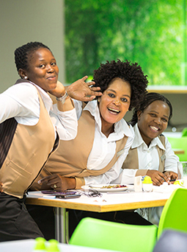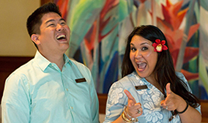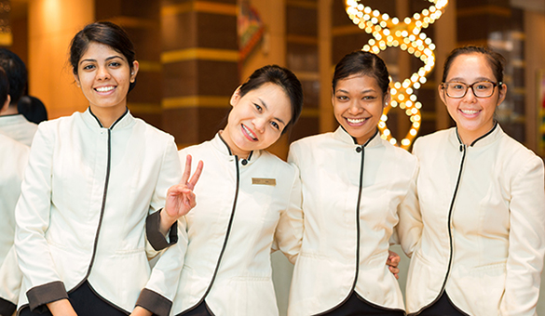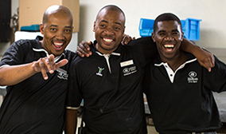

CATCH A FELLOW TEAM MEMBER TODAY.

Every day at our property, Team Members display countless acts of hospitality that positively impact Guests and fellow Team Members  
alike. The next time you see a Team Member doing something special, show your appreciation by catching him or her at their best. Cards   
are available at the front desk. You can also submit an eCatch online at  
www.Hilton-Recognition.com/eCatch.

JUNE 1 – AUGUST 31

CATCH ME

AT MY BEST

WHY SHOULD GUESTS HAVE ALL THE FUN?