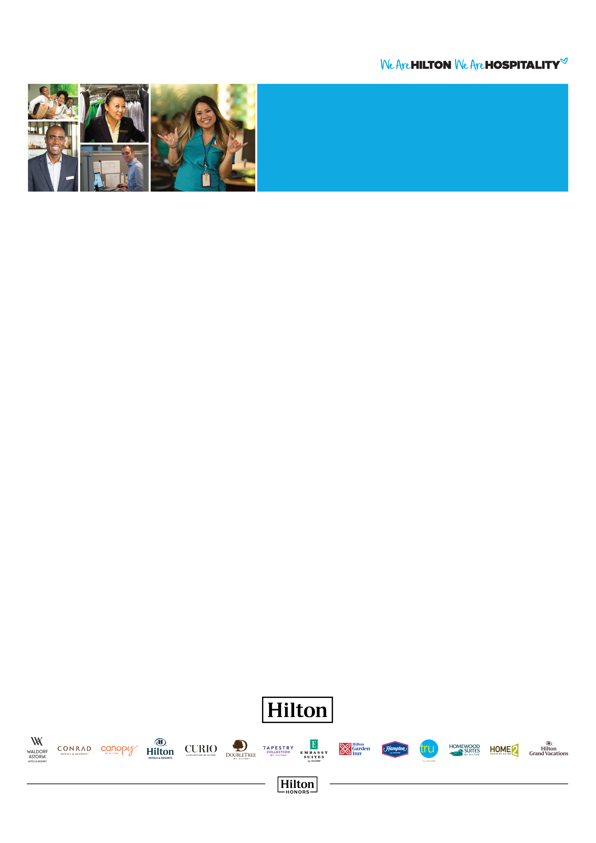

CATCH ME

AT MY BEST

To: Team Members

From: [INSERT YOUR NAME HERE]

Subject: 2018 Catch Me at My Best Program

LET’S DO WHAT WE DO BEST!

Catch Me at My Best is about to begin! It’s our way to celebrate and reinforce our commitment to Hospitality and the values that drive our success.

Catch Me provides us with the opportunity to recognize acts of hospitality, big and small, that make our hotel   
special—like remembering a Guest’s name, problem resolution, attention to detail, and cleanliness. [OPTIONAL NOTE TO HOTEL: USE THIS AREA TO INSERT SPECIFIC BEHAVIORS YOU WANT TO REINFORCE.]

The program runs from June 1 to August 31. During this time, Guests, managers, and peers can recognize Team Members by simply filling out a Catch Me card. The completed cards can be turned in at the front desk. Be sure all cards are turned in to [INSERT CENTRAL LOCATION OR POINT PERSON HERE] so they can tally the results.

[NOTE TO HOTEL: INSERT HOTEL SPECIFICS ABOUT PRIZES, THEMES, PARTIES, AND OTHER INFORMATION YOU’D LIKE TO COMMUNICATE TO YOUR TEAM ABOUT THIS YEAR’S PROGRAM].

And don’t forget, catching is not just for Guests. Be sure to recognize your fellow Team Members with a Catch Me card each time you see them doing something great!

So let’s make this our best Catch Me yet.